PAPPU KUMAR
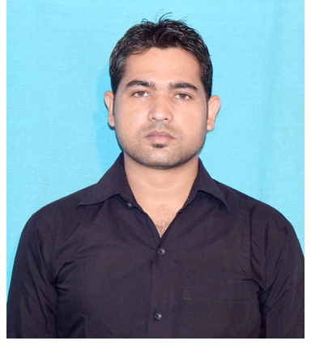
E-mail: pappukumaryadav1256@gmail.com
Phone: 07815961170,09122932139
Certification ID: 0014650425
Vearson : Netweaver 7.31

PROFESSIONAL SYNOPSIS

- Certified SAP ABAP NETWEAVER 7.31 Consultant from ATOS – SAP Authorized Training Center, KOLKATA

ACADEMIC CREDENTIALS

2010 - 2013 BACHELOR IN SCIENCE INFORMATION TECHNOLOGY (BSc.IT).
NIIT, PATNA . (58%)

2009 Higher Secondary (BSEB, PATNA).
MAHARAJA COLLEGE, ARA . (70%)

2007 Secondary (BSEB, PATNA).
R.K.S HIGH SCHOOL, KHURNU. (57%)

SAP CERTIFICATION

SAP ABAP Version Netweaver 7.31
ATOS INDIA PVT LTD.– SAP Authorized Training Center, KOLKATA
( 20st July 2015 – 21rd August 2015 )

Focus Areas:
- ABAP Database Dictionary – Table , View , Structure , Search Help.
- Runtime Analysis And Debugging
- Classical Report
- Screen Programming - Dialog Programming
- ALV - Docking Container , Custom Container
- ABAP OOPS
- Enhancement – Customer Exit , User Exit ,BADI , Enhancement Spot,
- Modification , Function Module.
- Field Symbol

Modules Covered:

- TAW10 – ABAP Workbench Fundamentals
- TAW12 – ABAP Workbench Concepts

IT SKILLS

- SAP ECC 6.0 ABAP 4.0 with Netweaver 7.31
- C , JAVA , Database Management System
- Information Risk and Security
- Computer Basics, MS Office, Internet.

EXTRA WORK EXPERIENCE

- 2013-14 work in FINO PAYTECH LTD. As a TECHNICAL SUPPORT EXECUTIVE.
- 2014-2015 work in domestic call center.

PERSONAL INFORMATION

Date of Birth : 10th 07 july 1992
Marital Status : Single
Language : Hindi, English,
Father’s Name : Mr. Sudarshan Singh
Mother’s Name: Mrs. Mira devi
Local Address : vill-Jigina,post-Baradih,p.s-Agrer
Dist-Rohtas, (Sasaram, Bihar) .
Pin code : 821305
Passport no. : P0560082

I hereby declare that all the above information given by me is true of my best knowledge.

Date:
Place:
Sign : (pappu kumar)

